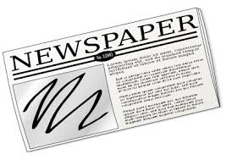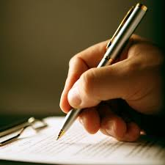Current Events

Current events will be completed in order to keep you aware of what is going on day to day as far as college and careers are concerned and to improve your skills in reading, writing, summarizing, and analyzing. This sheet explains the format of the current event you will turn in. Keep this sheet in your notebook. Please find additional information below.

John Doe

**Current Event Format**:

Your paper should be set up like this!

8/29/19

1st

How to Complete Current Events (title of article)

Writing and Winning Weekly (name of newspaper or magazine)

5/30/14 (date of newspaper/magazine)

(Skip this line.)

The first paragraph of your current event summary should include five to seven sentences that summarize the article. Be sure not to copy the article; it should be in your own words. It would be wise to first read the article, and then began writing the facts that you remember about the article. Include who or what the article involves, when and where it took place, action that took place, causes and/or solutions, and any other important information. Please do not include the name of the person who wrote the article. Make sure this paragraph is at least seven sentences but not more than ten and that it is written in your words. (DO NOT SKIP LINES BETWEEN PARAGRAPHS!)

The second paragraph should consist of five sentences in which you write your reaction and comments about the article. Discuss why it is or is not newsworthy. Discuss its importance and significance. Discuss how the article makes you feel or the emotions it evokes from you. Discuss whether it reminds you of an experience that you might have had. Relate any personal thoughts, feelings and reactions that you have to or about the article. Make sure this paragraph is at least seven sentences but not more than ten and that it is written in your words.

Source: Satalkar, B. (2010, July 15). *Water aerobics*. Retrieved from http://www.buzzle.com

**Additional Information:**

1. The source should be written in APA format. **You will lose 20 points off the grade for not including the source!**
2. Grammar, spelling, punctuation, and neatness will be checked as well. Stay in the margins!
3. Articles must be college or career focused!
4. Newspapers and magazines may be used, but you must have a hard copy of the article attached to your paper. (The State, The Augusta Chronicle, Aiken Standard, or USA Today, etc.).
5. Paragraphs must be at least 7 sentences.
6. Be sure to underline the name of the newspaper.
7. Try to choose articles that interest you.
8. Read the entire article then write what it was about. You will not receive credit for copying. Be sure to paraphrase.